**How to Install Sublime Text Editor on Ubuntu 16.04, 14.04 and 12.04 using PPA**

**Sublime Text** is a powerful text editor also available for Linux systems. It has lots of features which you must love to use. This article will help you for installing Sublime Text 2 and Sublime Text 3 on Ubuntu and Debian systems using apt-get ( ppa ).

**1. Features of Sublime Text:**

* Editing files side by side.
* Sublime Text is available for various plateform including OS X.
* It provides functionality to find and replace with regular expressions.
* We can make batch edits with multiple Selections.
* Using sublime multiple selections, we can rename variables quickly.
* The Command Palette gives fast access to functionality.
* Using goto anything to quickly navigate between files.
* Using goto anything can also be used to show a function, line or word within a file.

**2. Installi Sublime Text:**

There are two version’s of Sublime Text is available to install. Install any one version as per your requirements using following options on Ubuntu and Debian Systems.

**Install Sublime Text 2:**

$ sudo add-apt-repository ppa:webupd8team/sublime-text-2

$ sudo apt-get update

$ sudo apt-get install sublime-text

**Install Sublime Text 3:**

$ sudo add-apt-repository ppa:webupd8team/sublime-text-3

$ sudo apt-get update

$ sudo apt-get install sublime-text-installer

**Start Sublime Text:**

Use system navigation and start Sublime Text editor. Happy coding.

[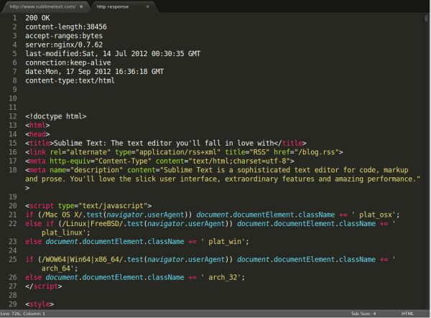](http://tecadmin.net/wp-content/uploads/2015/01/sublime-text-e1422075064821.png)